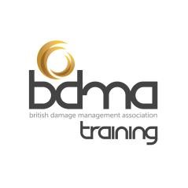
Guide for the BDMA Claims Technician Online Examination

Examination
The examination is based entirely on the syllabus which is published on the BDMA website, www.bdma.org.uk. Any other training courses or material will support your performance in the exam but it is recommended that you study the syllabus as widely as possible.

Examination structure
The time allowed to complete the examination is 3 hours. The test is made up of a combination of multiple-choice questions (MCQs) and written answers. There are 186 MCQs and 5 questions which need a written answer. The MCQs are worth 1 mark each and the marks for each written assignment are shown on the question. Note that there is only one correct answer for each question.
The MCQs make up 75% of the available marks and the questions that need a written answer make up 25% of the available marks.
The paper is split into 2 sections. The first section contains the multiple-choice questions and the second section contains the questions requiring a written answer.
The pass mark for the examination is 70%.

Training
The BDMA: Core Damage Management – Technician & Claims Technician – 2 day classroom course
The BDMA: e-Academy: Damage Management Training & Reference – BDMA e-Academy eLearning

Reading list
Customer Care Excellence. Sarah Cook: ISBN 0-749-45066-5
Principles of Health & Safety at work. Allan St John Holt, IOSH: ISBN-13: 978-1138855151

Periodicals / Magazines
The Standard (BDMA Quarterly Magazine)

Websites
Financial Conduct Authority (FCA): https://www.fca.org.uk/ - FCA Handbook, Treating Customers Fairly (use search facility on FSA website)
Chartered Institute of Environmental Health – www.cieh.org
Chartered Insurance Institute - www.cii.co.uk
British Institute of Cleaning Science – www.bics.org.uk
Business Link – www.businesslink.org.uk

