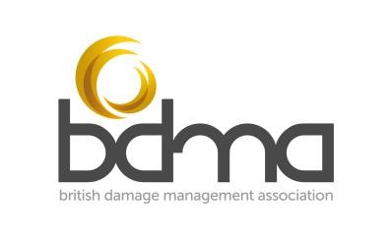
Candidate notes for BDMA Claims Technician Online Examination Candidates

Before the Examination

All candidates are required to upload a scanned copy or image of their photographic ID into the BDMA e-Academy, and complete the required information outlined in the Examination Supporting Documents enrolment.
All candidates will need access to their own device (ideally a PC, laptop or tablet) with full audio and video capability; a keyboard and mouse is recommended. Candidates are responsible for ensuring a consistent internet connection.
For the examination, candidates will need to ensure that they are in a quiet location where they can remain undisturbed for the duration of the exam (3 hours). The format of the exam is a closed book assessment so all notes, booklets etc will need to be removed from the area before the exam starts.
The exam will be invigilated using Zoom.

Prior to the examination, all candidates will be enrolled on ‘BDMA Practice Exam’ on the e-Academy. This is a familiarisation module for the formatting of the exam and will allow candidates to practice navigating questions, saving and submitting answers.

Examination rules:

- The exam is closed book, please clear your desk before the exam and be prepared to show the invigilator your desk using your camera
- Camera and sound must be kept on for the duration of the exam
- Ensure you are somewhere quiet where you can remain undisturbed for the 3-hour exam duration –this should be somewhere without background noise so that you don’t disturb the other candidates
- Please do not use virtual backgrounds on Zoom during the exam
- Please ensure that you are well lit and clearly visible or the invigilator may ask you to leave and retake the exam another time.
- Candidates must not speak to anyone, except the invigilator, during the exam
- Use the chat function to contact the invigilator / zoom host if you have a problem during the exam
- If you need to take a comfort break go ahead, but leave zoom running at your desk
- The exam is online, the invigilator will enrol you on the exam and you will either receive an email (or if you are already logged onto the BDMA eAcademy system you will see the exam appear on your dashboard)
- The invigilator will check that you have all received the email or are online and can see the exam – do not start the exam at this point
- When everyone has confirmed that they can see the exam the invigilator will announce the start of the exam
- When you have completed the multiple-choice section please submit your answers – when you have done this you won’t be able to go back and change them
- For the written assignments, scroll down and make sure you save your work on each assignment regularly. Submit each assignment when you are happy with your answer – you won’t be able to edit after you have submitted your answer. Each written assignment needs to be submitted individually
- The invigilator will give time checks at 1 hour, 30 minutes, 15 minutes and 5 minutes to go
- If you finish before the time has elapsed, message the invigilator using the chat function and they will check that everything has been submitted correctly before you leave
- For those remaining at the end of the exam the invigilator will check that everything has been submitted correctly so please stay in the room until it is confirmed that your exam is complete

Please note: The invigilator will make examiners aware if, in their opinion, the examination or registration procedures have not been adhered to by a candidate.

